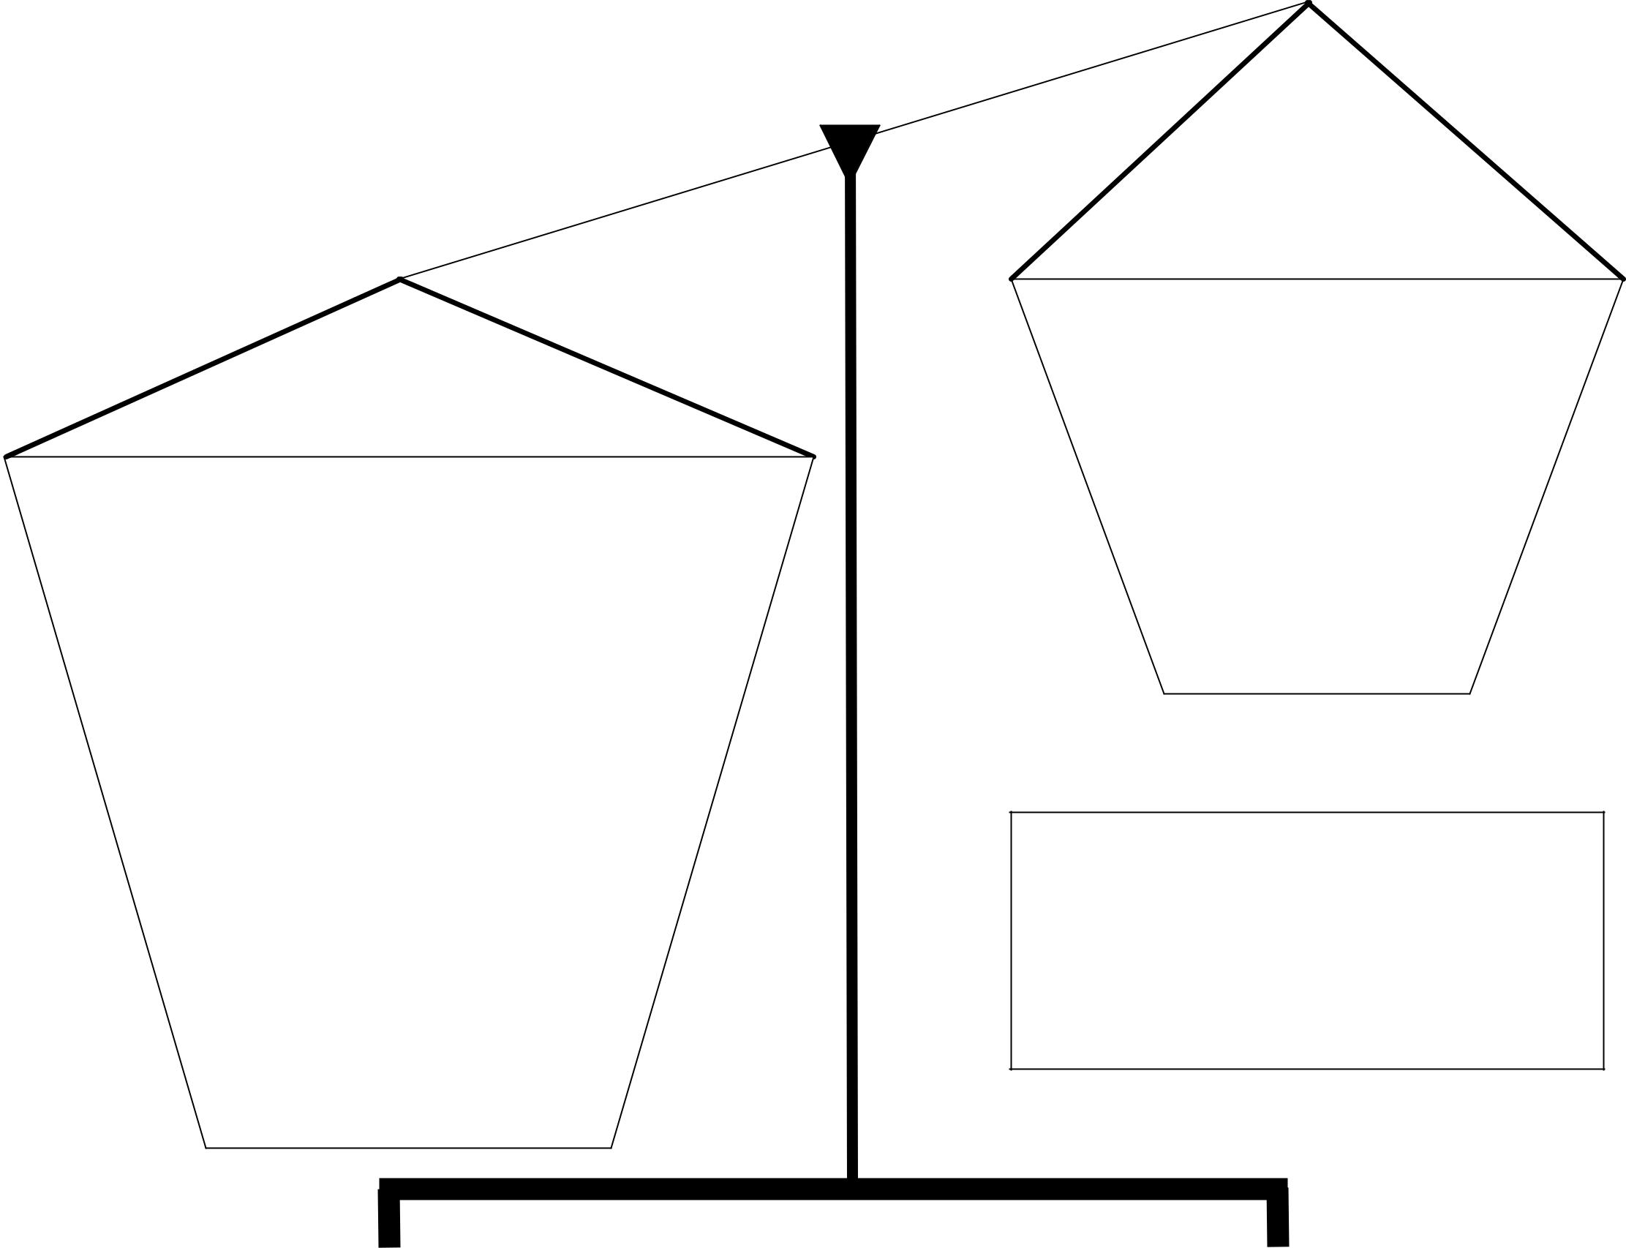

Strengths

Weaknesses

Articles of

Confederation

