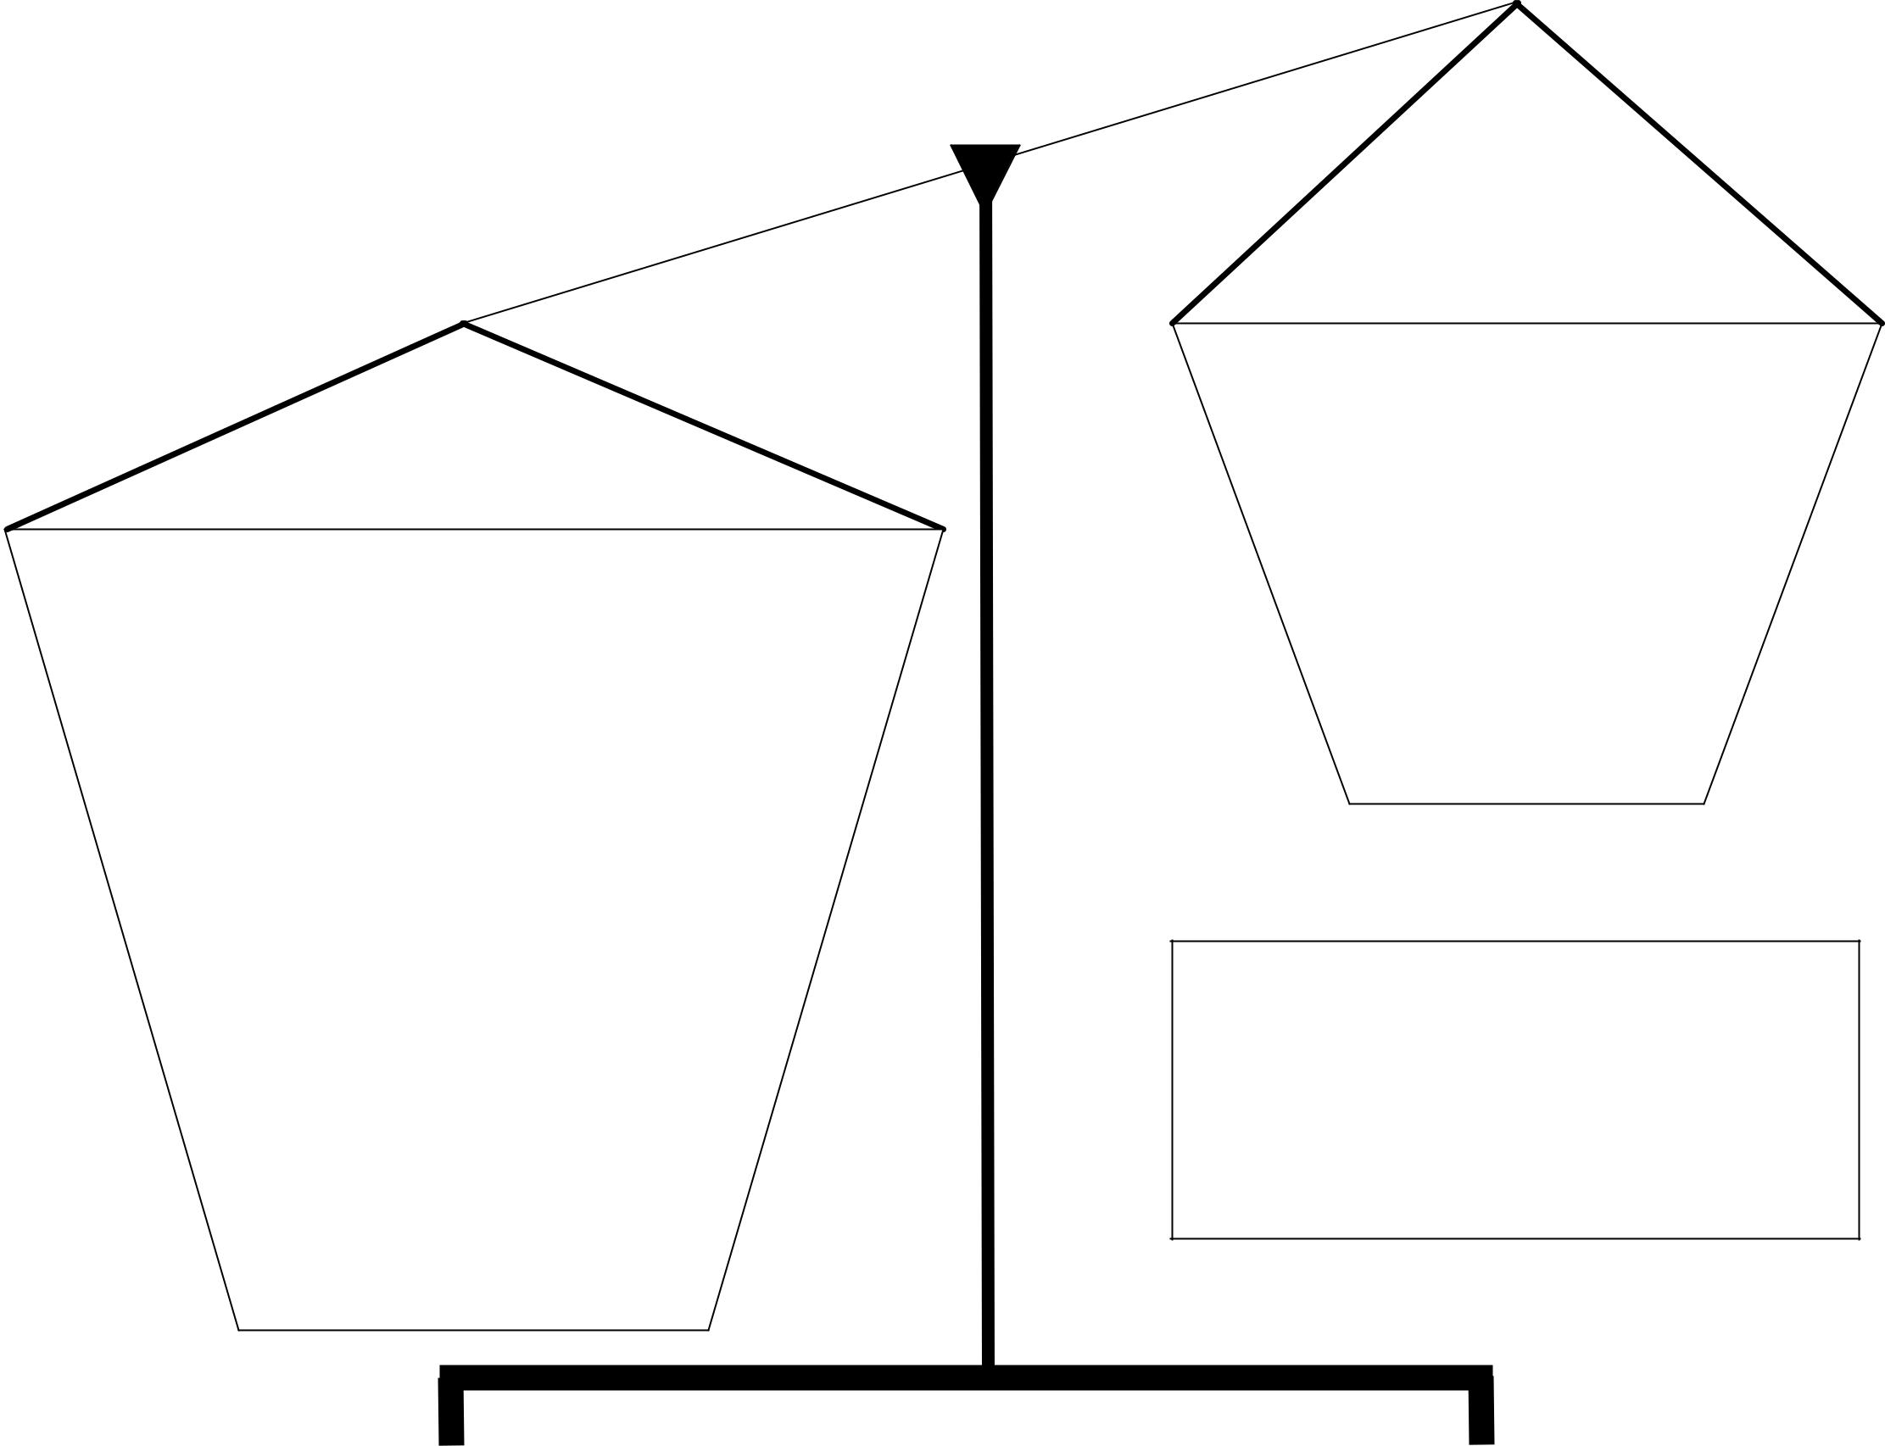

Strengths

Weaknesses

Georgia Constitution of 1777

