You have ALL the tools you need in order to learn, know, and understand all of the required standards for 8th grade social studies.
8th grade
Social Studies
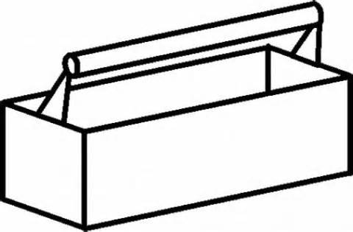

The MAIN items in your "tool box" include: Georgia Virtual Learning, our Online Textbook, the Georgia Teacher Notes from the Georgia Standards.org website, as well as USA Test Prep.

HOW TO ACCESS THESE TOOLS: Go to my web page and clink on TOOL BOX. Once there:

1. Open the TEACHER NOTES. Scroll until you find the standards you are looking for. You can print (just the pages you need - not all 144!!!) and highlight important information. You can make flash cards or Quizlet cards. You can make graphic organizers with the teacher notes, or use them to answer homework or in-class questions. There are many ways you can take notes!

2. Open GEORGIA VIRTUAL LEARNING. You will notice that you land on the 8th grade Social Studies page (but, on the left, you can click on Courses, and then click on some of your other classes). Once on the Social Studies page, click the VIEW button on the right for whichever topic you need to review. Click view and then work your way through the tasks. You can always go back to the teacher pages to help you with this.

3. Click on OUR TEXTBOOK. Choose the appropriate unit (look at the unit headings! What have we been discussing in class?) Use the buttons at the top left to navigate through the various chapters. REMEMBER: this textbook is interactive. You can click on pictures to learn more. Do any tasks or answer any questions you find in the textbook to help you learn, remember, and understand what we have been discussing in class. Summarize the topics in your binder under “units” section.

4. Click on USA TEST PREP. Once here, you have several options. If your teachers have assigned work to you, scroll down until you see the work. Click and complete the work. If NO WORK has been assigned, and you want to complete some practice work (once you have done 1, 2, 3 above), click on 8TH GMAS at the top of the page. Then, click on Social Studies. Then, you will need to FIND the standards that you need to work on. Is it History, Geography, Government/Civics, or Economy you need to work on? You know what you need help in. Click on that standard and then complete the tasks that come up.

Once ALL OF THE ABOVE is completed, let your teacher know you have completed work in USATEST PREP. I will look at those USATest Prep scores and adjust your grade accordingly.

